**CUCUMBER ASSIGNMENT**

**Q) Please do the following assignment for cucumber framework -**

**1. Install Cucumber**

A) Added the following dependencies :

<dependency>  
 <groupId>io.cucumber</groupId>  
 <artifactId>cucumber-java</artifactId>  
 <version>7.11.1</version>  
</dependency>  
  
<dependency>  
 <groupId>io.cucumber</groupId>  
 <artifactId>cucumber-testng</artifactId>  
 <version>7.11.1</version>  
</dependency>

**2. Create a Cucumber project**

A) created project “CucumberAssignment”

**3. Use the attached feature file and implement the stepDefinitions for all the scenarios in the feature file. (You can use dummy code in the stepDefinition methods)**

**4. Execute TestRunner.**

A) Scenario 1

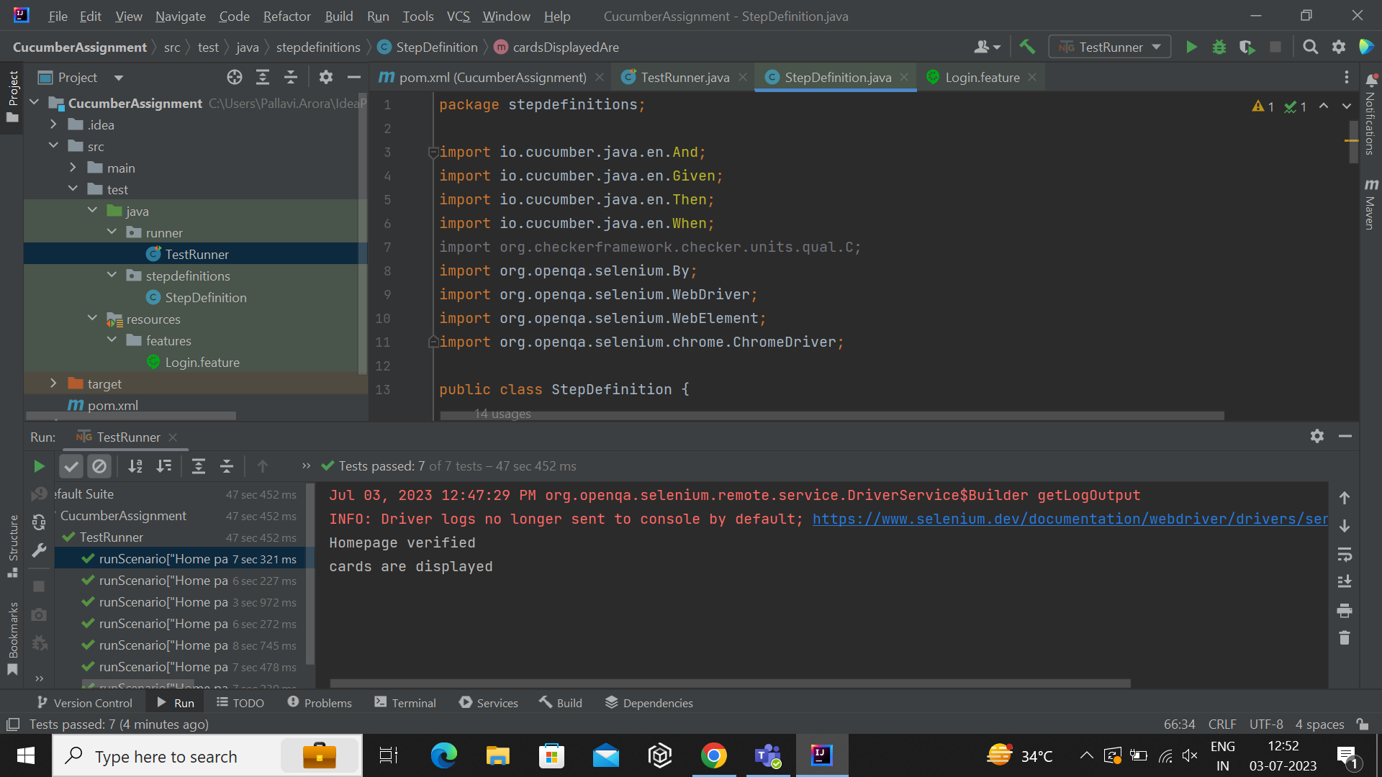

Scenario 2

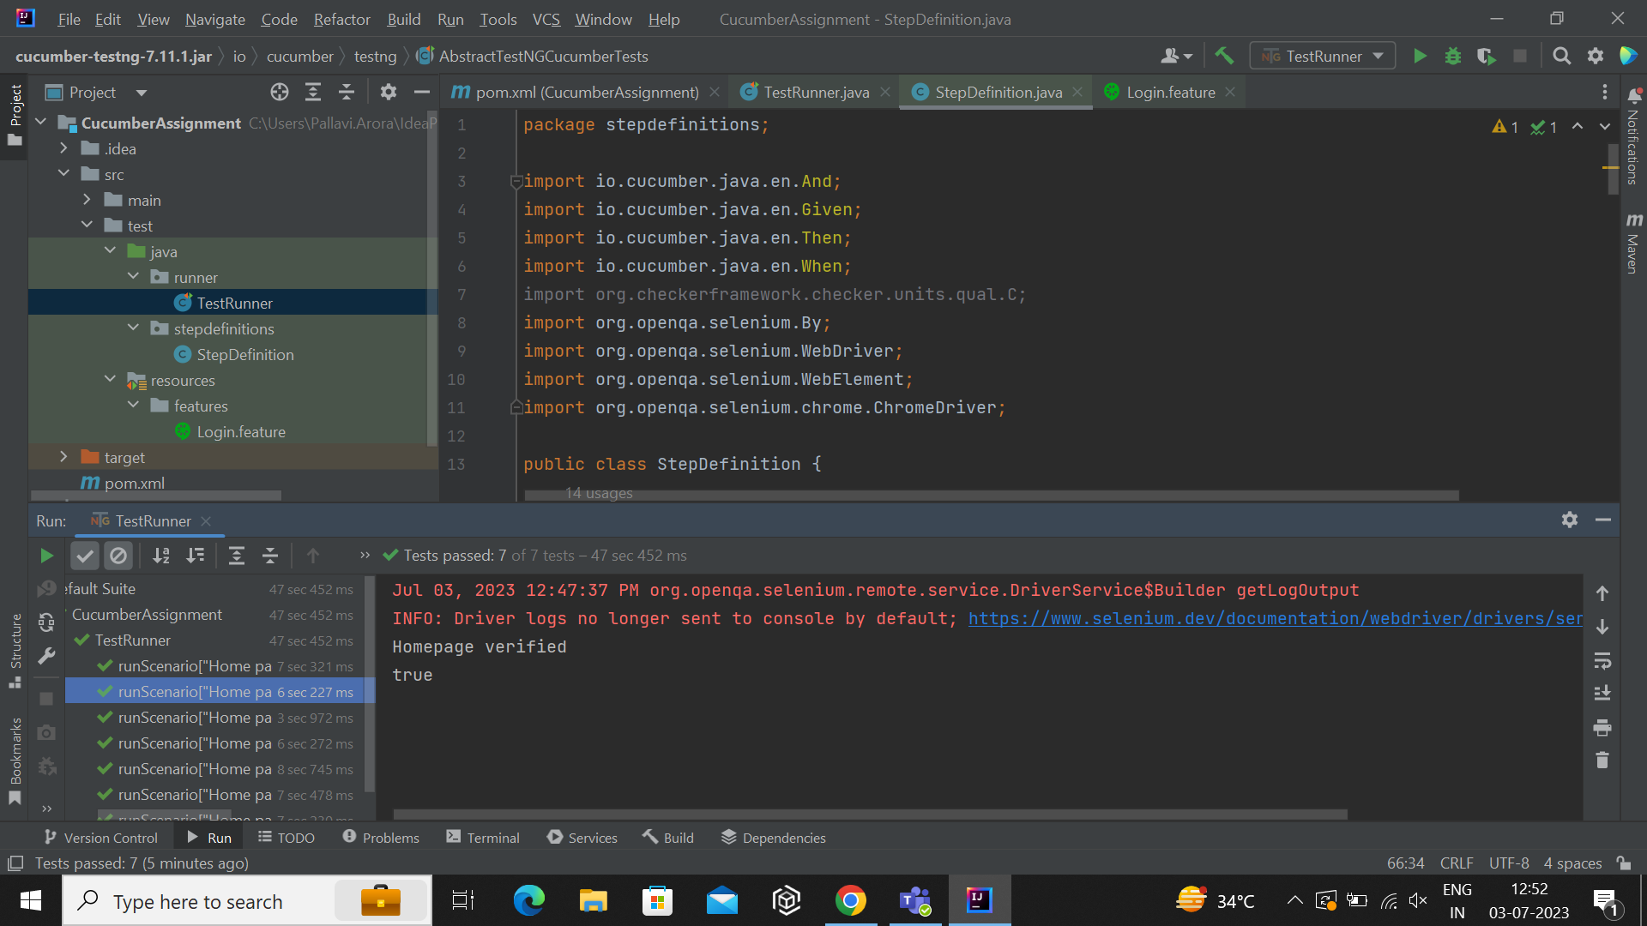

Scenario 3

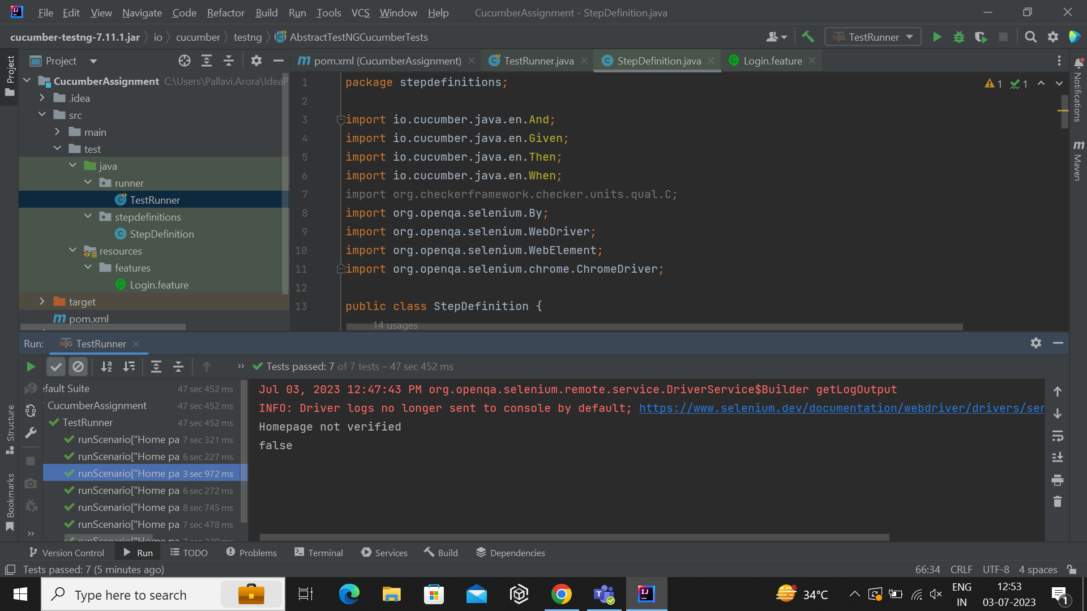

Scenario 4

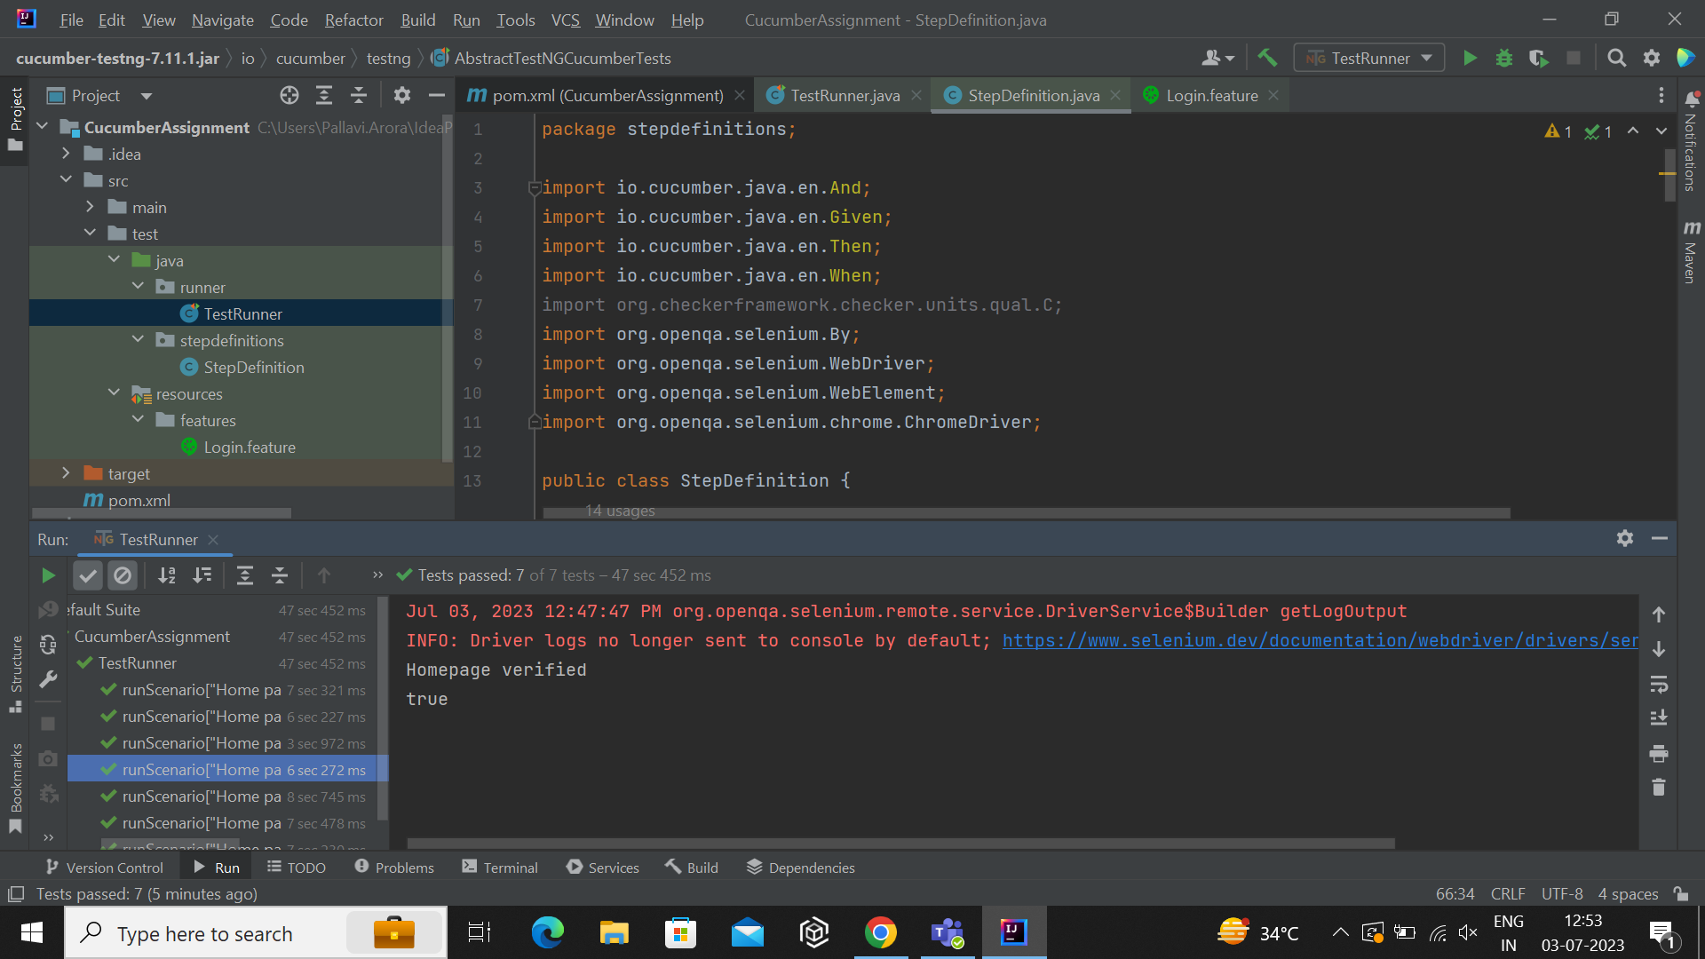

**5. Assign tags to specific scenarios in the feature file, and execute TestRunner for those particular tags.**

A) Tag assigned - @SmokeTests to Scenario 1 and 2

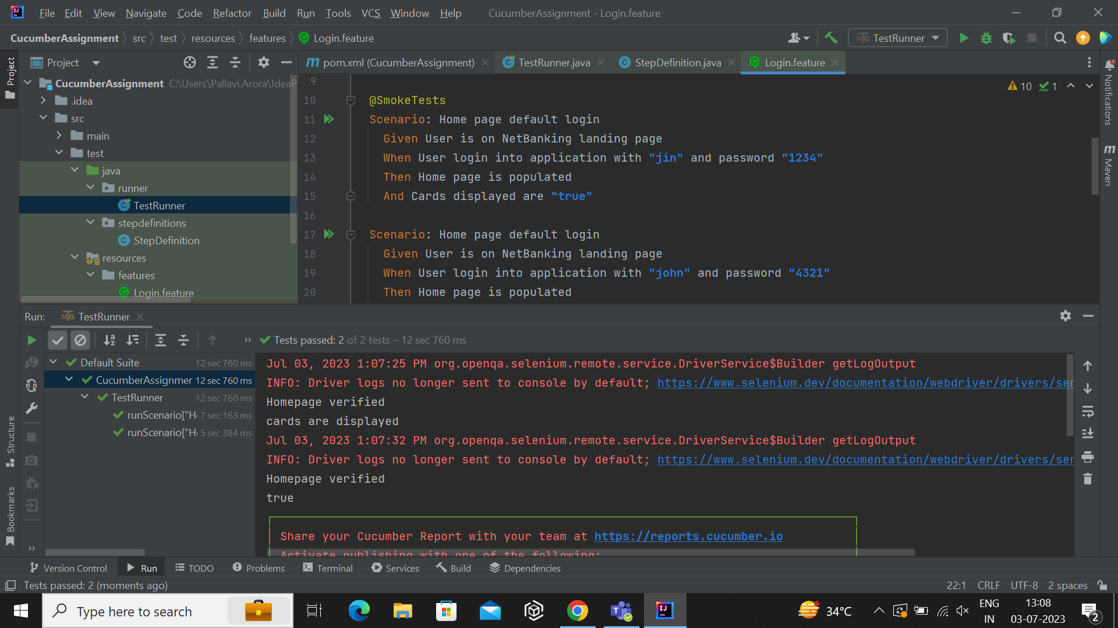

**CODE**

**TestRunner**

package runner;  
  
import io.cucumber.testng.AbstractTestNGCucumberTests;  
import io.cucumber.testng.CucumberOptions;

//giving path of stepdefinition and features file  
@CucumberOptions(  
 glue ="stepdefinitions",  
 features = "src/test/resources/features",

//giving tag to only execute particular scenerios  
 tags = "@SmokeTests"  
)  
public class TestRunner extends AbstractTestNGCucumberTests {  
}

**StepDefinition**

package stepdefinitions;  
  
import io.cucumber.java.en.And;  
import io.cucumber.java.en.Given;  
import io.cucumber.java.en.Then;  
import io.cucumber.java.en.When;  
import org.openqa.selenium.By;  
import org.openqa.selenium.WebDriver;  
import org.openqa.selenium.WebElement;  
import org.openqa.selenium.chrome.ChromeDriver;  
  
public class StepDefinition {  
 WebDriver driver = null;  
 @Given("User is on NetBanking landing page")  
 public void userIsOnNetBankingLandingPage() {  
 driver = new ChromeDriver();  
 driver.manage().window().maximize();

//opeining link  
 driver.get("https://parabank.parasoft.com/parabank/index.htm?ConnType=JDBC");  
 }  
  
 @When("User login into application with username and password")  
 public void userLoginIntoApplicationWithUsernameAndPassword() {

//entering username  
 WebElement username = driver.findElement(By.*name*("username"));  
 username.sendKeys("test.user");

//entering password  
 WebElement password = driver.findElement(By.*name*("password"));  
 password.sendKeys("abcd");

//clicking on login  
 WebElement login = driver.findElement(By.*xpath*("//div[@class='login']//input[@type='submit']"));  
 login.click();  
 }  
  
 @Then("Home page is populated")  
 public void homePageIsPopulated() {

//verifying homepage  
 String homepage = driver.getTitle();  
 if(homepage.contains("ParaBank | Accounts Overview")) {  
 System.*out*.println("Homepage verified");  
 }  
 else {  
 System.*out*.println("Homepage not verified");  
 }  
 }  
  
 @And("Cards are displayed")  
 public void cardsAreDisplayed() {

//verifying element on page  
 WebElement card = driver.findElement(By.*id*("rightPanel"));  
 if(card.isDisplayed()) {  
 System.*out*.println("cards are displayed");  
 }  
 else {  
 System.*out*.println("card not displayed");  
 }  
 }  
  
 @When("User login into application with {string} and password {string}")  
 public void userLoginIntoApplicationWithAndPassword(String arg0, String arg1) {

//entering provided username and password  
 WebElement username = driver.findElement(By.*name*("username"));  
 username.sendKeys(arg0);  
 WebElement password = driver.findElement(By.*name*("password"));  
 password.sendKeys(arg1);  
 WebElement login = driver.findElement(By.*xpath*("//div[@class='login']//input[@type='submit']"));  
 login.click();  
 }  
  
 @And("Cards displayed are {string}")  
 public void cardsDisplayedAre(String arg0) {  
 System.*out*.println(arg0);  
 }  
  
 @When("User login in to application with {string} and password {string}")  
 public void userLoginInToApplicationWithAndPassword(String arg0, String arg1) {  
 WebElement username = driver.findElement(By.*name*("username"));  
 username.sendKeys(arg0);  
 WebElement password = driver.findElement(By.*name*("password"));  
 password.sendKeys(arg1);  
 WebElement login = driver.findElement(By.*xpath*("//div[@class='login']//input[@type='submit']"));  
 login.click();  
 }  
}